ISD 2023 - Week 4 Assignment

There are 10 questions for a total of 20 marks.

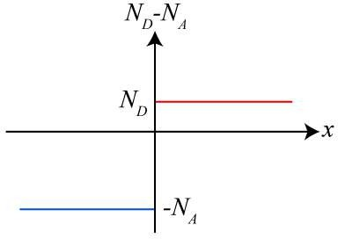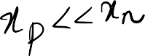**For Q1-Q2**: Consider a abrupt silicon pn junction with doping profile as shown in the figure below. Based on the doping profile, answer the questions that follow.

1. (2 marks) The corresponding charge configuration of the pn junction is depicted in figure .

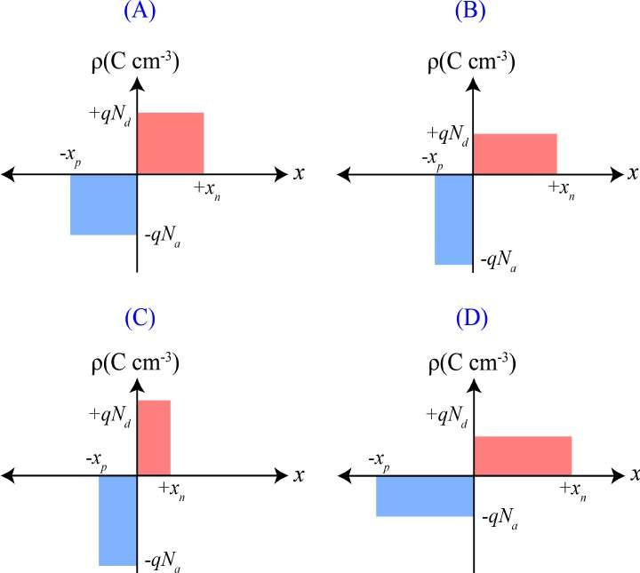

* 1. A

# B

* 1. C
  2. D

1. (2 marks) Identify the corresponding electric field profile at the pn junction from the figure below.

# A

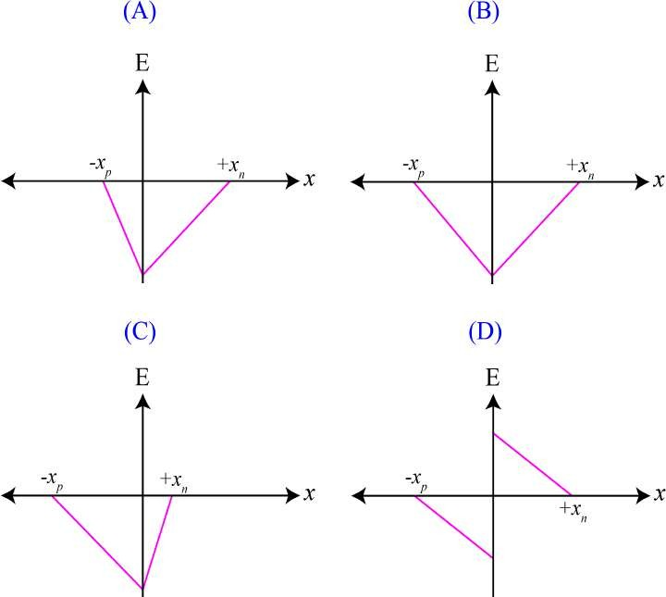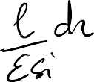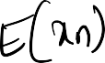

* 1. B 
  2. C
  3. D

 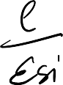 

 





Dr. Naresh Kumar Emani, EE @ IIT Hyderabad

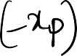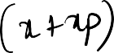

Page 2

**For Q3-Q4**: The doping profile of a hypothetical silicon pn junction is shown in the figure below. Based on the doping profile, answer the questions that follow.

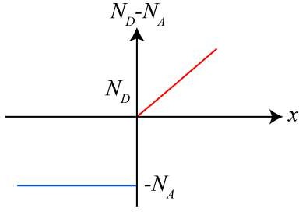



1. (2 marks) The corresponding charge configuration of the pn junction is depicted in figure .

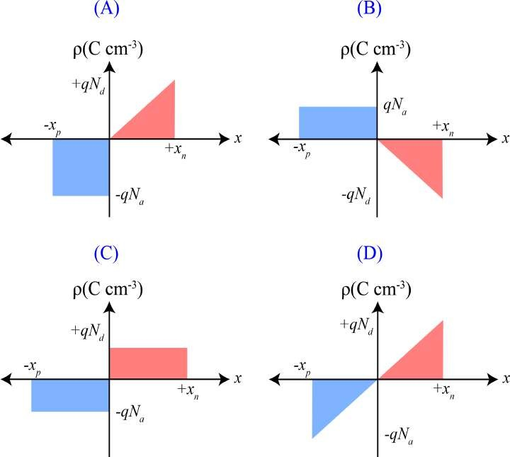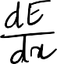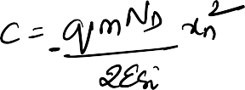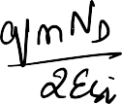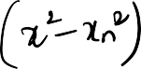



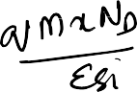

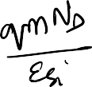 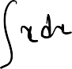

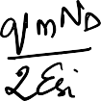

# A

* 1. B
  2. C
  3. D

1. 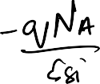(2 marks) Identify the corresponding field profile at the pn junction from the figure below.

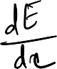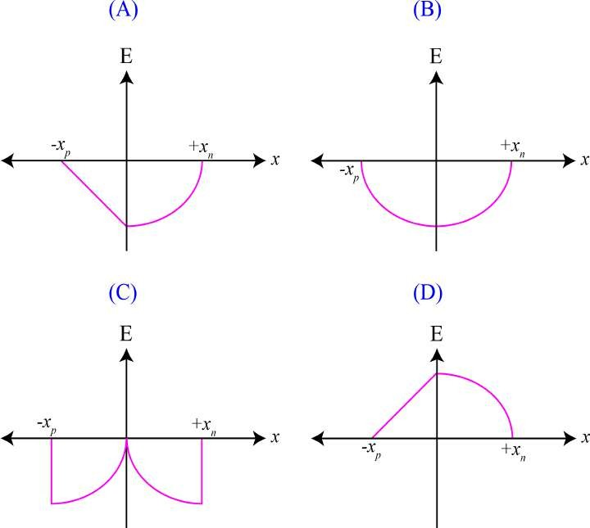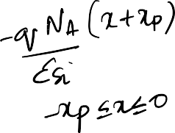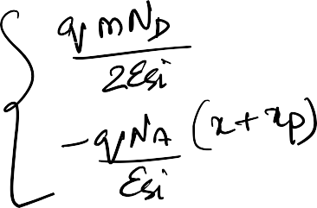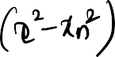

1. **A**
2. B
3. C

D. D

**Reflect and remember:** The important point to remember here is that the approximations made to the doping profile are sufficient to give us a qualitative understanding of the junction behaviour. We also emphasize the fact that trying to remember the field profiles is futile. It is always a good practice to start from the charge configuration and work towards deriving the fields using Poisson’s equation. You should also know why the field goes to zero far away from the junction.

**For Q6-Q9:** The doping concentrations in an abrupt silicon pn junction at T = 300 K are N*a* = 1012 cm*—*3 and N*d* = 1016 cm*—*3. Take the intrinsic concentration of undoped silicon as n*i* = 1 ⇥ 1010 cm*—*3, kT/q = 25 mV at 300 K, ✏*Si* = 11.9, ✏0 = 8.85 ⇥ 10*—*14 Fcm*—*1, and the depletion width (w) of the pn junction as 24.6 µm.

1. (2 marks) The built-in voltage of the pn junction is V . A. 0.692 

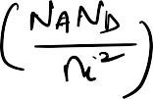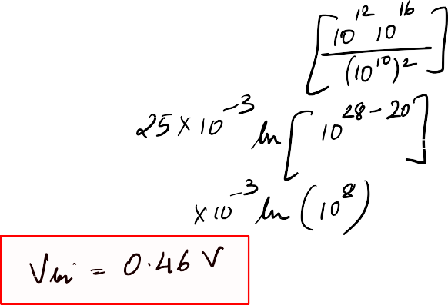

B. 0.871

C. 1.21

**D.** 0.46

E. 0.92

1. 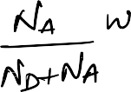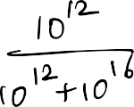(2 marks) The depletion width on the n—side of the pn junction, x*n*, is µm.

A. 24.6  

**B.** 2.46 ⇥ 10*—*3

C. 12 ⇥ 10*—*4

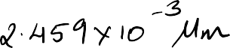

D. 12

E. 0.12

1. 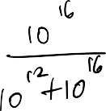(2 marks) The depletion width on the p—side of the pn junction, x*p*, is µm.

**A.** 24.59 

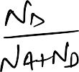

B. 12 ⇥ 10*—*4

C. 12



D. 0.12

E. 24.59 ⇥ 10*—*3

1. 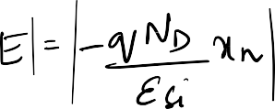(2 marks) The magnitude of electric field across the pn junction is V cm*—*1.

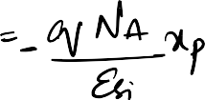

**A.** 3.73 ⇥ 102

B. 37.3

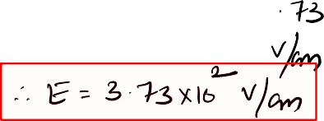

C. 186

D. 3.73 ⇥ 104

E. 1.86 ⇥ 104

**Reflect and remember:** The above problem demonstrates that, when a pn junction is heavily doped on one side, the majority of the depletion width lies in the side which is lightly doped. The heavily doped side is often hardly depleted at all.

1. 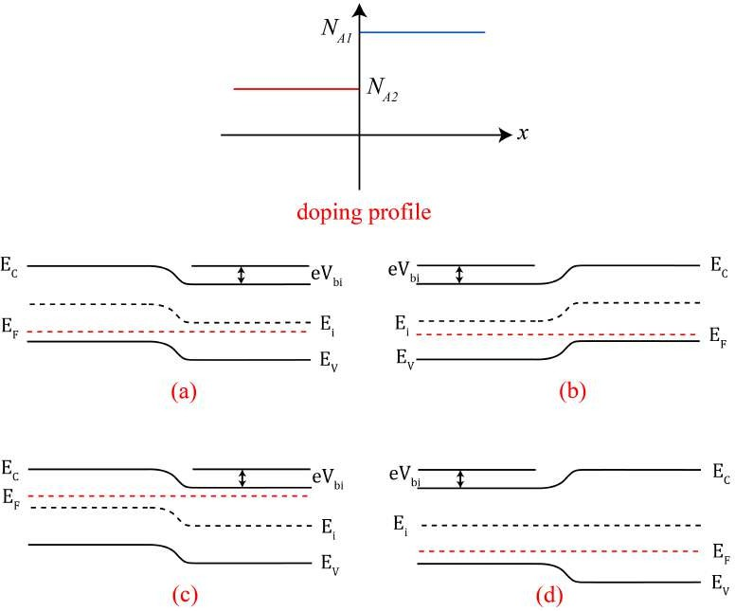(2 marks) Consider a p1 — p2 silicon ”isotype” junction with a doping profile as shown in the figure below. Choose the correct band diagram representing the junction from the options given below.
   1. A

# B

* 1. C
  2. D

**Reflect and remember:** One important point to remember here is that there are no donor atoms present in the aforementioned iso-junction. Here, the hole concentration for x > 0 is in excess compared to x < 0. Holes from x > 0 will di↵use into x < 0, leaving behind a net negative charge. The net negative charge left behind in the x > 0 region is balanced by the free carrier holes di↵used into x < 0.

1. (2 marks) **(EC-GATE 2018)** A junction is made between p*—* Si with doping density N*a*1 = 1015cm*—*3 and p-Si with doping density N*a*2 = 1017cm*—*3. Assume T = 300 K and calculate the magnitude of built-in potential (in V ) across the junction.

A. 0.08

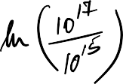B. 0.2  

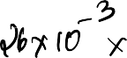**C.** 0.12

D. 1.02



E. 1.2